PostgreSQL Exam Preparation II

Submit your solutions to the SoftUni Judge Contest.

Taxi Company
As one of the top-performing students at SoftUni, you have been assigned the challenging responsibility of designing a sample database for a new venture - a taxi company. Despite being less familiar with this industry, you will be provided with a comprehensive document outlining the requirements for this database. Additionally, you will receive test data that will enable you to conduct thorough testing and demonstrate your successful completion of the task.

Section 1. Data Definition Language (DDL) - (30 pts)
You have been provided with an E/R Diagram depicting the structure of the Taxi Company.
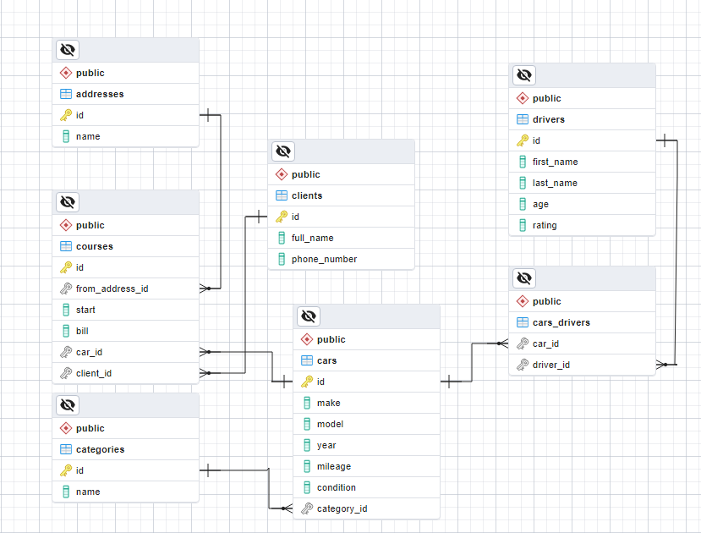
Create a PostgreSQL database named "taxi_db" and design the following tables:
- "addresses" - contains information about the addresses;
- "categories" - stores information about the categories;
- "clients" - stores information about the clients;
- "drivers" - holds information about the drivers;
- "cars" - contains information about the cars.
- "courses" - stores information about the courses.
- "cars_drivers" - serves as a many-to-many mapping table between cars and drivers.

NOTE: Please ensure that you use the exact data types specified in the model tables when working with dates. For instance, if a column is of type "DATE," make sure to use the "DATE" type. Similarly, if a column is of type "TIMESTAMP" use the "TIMESTAMP" data type. Failure to use the correct data types may result in the Judge system rejecting your submission as incorrect.
Your first assignment is to create the database tables based on the provided models. Follow the given specifications to create the tables.

addresses
Column Name | Data Type | Constraints
id | Integer from 0 to 2,147,483,647 | Primary Key, Unique table identification, Auto-increment
name | String up to 100 symbols | NULL is not allowed

categories
Column Name | Data Type | Constraints
id | Integer from 0 to 2,147,483,647 | Primary Key, Unique table identification, Auto-increment
name | String up to 10 symbols | NULL is not allowed

clients
Column Name | Data Type | Constraints
id | Integer from 0 to 2,147,483,647 | Primary Key, Unique table identification, Auto-increment
full_name | String up to 50 symbols | NULL is not allowed
phone_number | String up to 20 symbols | NULL is not allowed

drivers
Column Name | Data Type | Constraints
id | Integer from 0 to 2,147,483,647 | Primary Key, Unique table identification, Auto-increment
first_name | String up to 30 symbols | NULL is not allowed
last_name | String up to 30 symbols | NULL is not allowed
age | Integer from 0 to 2,147,483,647 | NULL is not allowed, Must be a positive number
rating | Numeric number with two-digit precision | The DEFAULT value is 5.5  NULL is permitted

cars
Column Name | Data Type | Constraints
id | Integer from 0 to 2,147,483,647 | Primary Key, Unique table identification, Auto-increment
make | String up to 20 symbols | NULL is not allowed
model | String up to 20 symbols | NULL is permitted
year | Integer from 1 to 2,147,483,647 | The DEFAULT value is 1, the column must always have a value greater than zero  NULL is not allowed
mileage | Integer from 1 to 2,147,483,647 | The DEFAULT value is 1, the column must always have a value greater than zero  NULL is permitted
condition | String limited to 1 character | NULL is not allowed
category_id | Integer from 0 to 2,147,483,647 | Relationship with table categories, Cascade Operations, NULL is not allowed

courses
Column Name | Data Type | Constraints
id | Integer from 0 to 2,147,483,647 | Primary Key, Unique table identification, Auto-increment
from_address_id | Integer from 0 to 2,147,483,647 | Relationship with table addresses, Cascade Operations, NULL is not allowed
start | TIMESTAMP when the course starts | NULL is not allowed
bill | Numeric number with ten-digit precision and two-digit scale | The DEFAULT value is 10, the column must always have a value greater than zero  NULL is permitted
car_id | Integer from 0 to 2,147,483,647 | Relationship with table cars, Cascade Operations,  NULL is not allowed
client_id | Integer from 0 to 2,147,483,647 | Relationship with table clients, Cascade Operations, NULL is not allowed

cars_drivers
Column Name | Data Type | Constraints
car_id | Integer from 0 to 2,147,483,647 | Relationship with table cars, Cascade Operations,  NULL is not allowed
driver_id | Integer from 0 to 2,147,483,647 | Relationship with table drivers, Cascade Operations,  NULL is not allowed

Database Design
Submit only your CREATE statements for all tables to the Judge.

Section 2. Data Manipulation Language (DML) - (10 pts)
Prior to beginning, it is necessary to import "dataset.sql". If the structure has been properly created, the data should be inserted successfully.
In this scenario, you have multiple tasks that involve manipulating the database, such as modifying data and adding new entries.

Insert
When drivers require transportation and are not working, they should be registered as customers in the database. Your task is to insert records into the "clients" table based on the "drivers" table. Specifically, for drivers with an "id" between 10 and 20 (inclusive), you need to insert data into the "clients" table with the following values:
- "full_name" - combine the "first_name" and "last_name" of the driver, separated by a single space;
- "phone_number" - set it to begin with "(088) 9999" followed by the driver's "id" multiplied by 2. For instance, if the driver's "id" is 10, the phone number should be "(088) 999920".

Example
id | full_name | phone_number
1 | Kalindi Keningham | (704) 2502909
2 | Lois Leidl | (933) 4279635
3 | Casi Farens | (933) 4275652
… | … | …
99 | Marsha Cridge | (230) 6839868
100 | Elysha Maydwell | (842) 4057110
101 | Delaney Stove | (088) 999920
102 | Ilaire Tomaszewicz | (088) 999922
103 | Genna Jaquet | (088) 999924
104 | Carlotta Dykas | (088) 999926
… | … | …
110 | Roddie Gribben | (088) 999938
111 | Boyce Briddock | (088) 999940

Update
To account for the wear and tear that occurs over time and long distances, it is necessary to update the condition of "cars" in the database. All cars meeting the following criteria should be updated to have a "condition" of 'C':
- the cars must have a "mileage" greater than 800,000 (inclusive) or have a NULL value;
- the cars must be older than or equal to 2010;
- cars with a "make" value of 'Mercedes-Benz' should be skipped, as they are expected to continue functioning well.

Example
Before update
id | make | model | year | mileage | condition | category_id
1 | Land Rover | Range Rover | 2021 | 550259 | A | 3
2 | GMC | Sierra 3500 | 2012 | 275538 | A | 4
3 | Infiniti | IPL G | 2004 | [null] | B | 1
… | … | … | … | … | … | …
18 | Infiniti | G35 | 2004 | [null] | A | 2
… | … | … | … | … | … | …
26 | Volkswagen | Jetta | 2002 | 345452 | C | 3
27 | Aston Martin | Vantage | 2010 | 890984 | C | 4
… | … | … | … | … | … | …
36 | Mitsubishi | Pajero | 2005 | 921496 | B | 4
… | … | … | … | … | … | …

After update
id | make | model | year | mileage | condition | category_id
1 | Land Rover | Range Rover | 2021 | 550259 | A | 3
2 | GMC | Sierra 3500 | 2012 | 275538 | A | 4
3 | Infiniti | IPL G | 2004 | [null] | C | 1
… | … | … | … | … | … | …
18 | Infiniti | G35 | 2004 | [null] | C | 2
… | … | … | … | … | … | …
26 | Volkswagen | Jetta | 2002 | 345452 | C | 3
27 | Aston Martin | Vantage | 2010 | 890984 | C | 4
… | … | … | … | … | … | …
36 | Mitsubishi | Pajero | 2005 | 921496 | C | 4
… | … | … | … | … | … | …

Delete
As part of the assignment, you are tasked with removing "clients" from the database who have not recently used the services of the company. The criteria for removal are as follows: delete all clients from the clients table who do not have any associated courses and have a "full_name" length greater than 3 characters.

Example
Before delete
id | full_name | phone_number
1 | Kalindi Keningham | (704) 2502909
2 | Lois Leidl | (933) 4279635
3 | Casi Farens | (933) 4275652
4 | Janna Kellert | (353) 9465732
… | … | …
10 | Meris Shale | (842) 4350411
11 | Colline Dann | (698) 8299305
12 | Joyann Garrettson | (858) 8642667
13 | Shane Arr | (261) 2901780
14 | Owen Strivens | (807) 1053029
… | … | …

After delete
id | full_name | phone_number
2 | Lois Leidl | (933) 4279635
4 | Janna Kellert | (353) 9465732
… | … | …
12 | Joyann Garrettson | (858) 8642667
14 | Owen Strivens | (807) 1053029
… | … | …

Section 3. Querying - (40 pts)
Now we will perform some data extraction tasks. Please note that the example results provided in this section are based on a fresh database. It is highly recommended to clear the database that was manipulated in the previous problems from the DML section and insert the given dataset again to ensure consistency with the examples in this section.

Cars
Extract information about all the "cars", including their "make", "model", and "condition". Sort the results in ascending order based on the car's "id".

Example
make | model | condition
Land Rover | Range Rover | A
GMC | Sierra 3500 | A
Infiniti | IPL G | B
Pontiac | Grand Prix | C
… | … | …
Ford | E250 | C
Infiniti | EX | C

Drivers and Cars
Retrieve comprehensive information about drivers and their cars. Extract the "first_name" and "last_name" of each driver, along with the "make", "model", and "mileage" of their cars. Arrange the results in descending order of "mileage". If there are any drivers with the same mileage, sort them alphabetically by "first_name". Exclude any cars that have a NULL value for "mileage".

Example
first_name | last_name | make | model | mileage
Edna | Heatley | Pontiac | Trans Sport | 967608
Delaney | Stove | Pontiac | Fiero | 959778
Cristi | Ravenshear | Maserati | GranTurismo | 954606
… | … | … | … | …
Ailina | Sebyer | Mercedes-Benz | G-Class | 6482
Gerhard | Alderson | Mercedes-Benz | G-Class | 6482

Number of Courses for Each Car
Your task is to write an SQL query that retrieves information from the database regarding all the cars and the count of their courses. Additionally, you need to display the "average_bill" of each course for each car, rounded to the second decimal digit. The results should be ordered in descending order based on the "count_of_courses". In case multiple cars have the same number of courses, the results should be further ordered by the car's "id". You should exclude cars that have exactly 2 courses from the results.

Example
car_id | make | mileage | count_of_courses | average_bill
13 | Mercedes-Benz | 846549 | 4 | 26.95
80 | Lincoln | 711184 | 4 | 22.39
1 | Land Rover | 550259 | 3 | 14.71
… | … | … | … | …
89 | Pontiac | 890015 | 0 | [null]
90 | Mercedes-Benz | 6482 | 0 | [null]
95 | Land Rover | 176967 | 0 | [null]

Regular Clients
Extract details of regular clients who have traveled in multiple cars. Filter the clients based on the condition that the second letter of their full name is 'a'. Retrieve the "full_name", and "count_of_cars" they have traveled in and the "total_sum" of their course bills. Sort the result by the "full_names" of the clients.

Example
full_name | count_of_cars | total_sum
Haven Seaton | 4 | 129.65
Jacquelynn Plackstone | 2 | 64.36
Kaylee Coushe | 4 | 135.71
… | … | …
Raynor Dobbison | 2 | 66.77

Full Information of Courses
The headquarters has requested a query to retrieve comprehensive information about all courses in the database. The required information includes the "address", whether the course was conducted during the 'Day' (between 6 and 20, inclusive) or the 'Night'(between 21 and 5, inclusive), the course "bill", the "full_name" of the client, the car "make", "model", and the "category_name". The results should be ordered by the course "id".

Example
address | day_time | bill | full_name | make | model | category_name
2 Del Mar Park | Night | 46.92 | Randie Cridge | Mitsubishi | Galant | Hatchback
24402 Warner Place | Day | 14.47 | Henrik Sivyer | Lincoln | MKT | Hatchback
80678 Green Ridge Court | Day | 44.01 | Randie Cridge | Isuzu | Rodeo Sport | Cabrio
… | … | … | … | … | … | …
34 Briar Crest Crossing | Night | 14.86 | Georges Lanston | Isuzu | Rodeo Sport | Cabrio
86462 Buena Vista Point | Day | 16.06 | Jefferson Montacute | Buick | Hearse | Coupe

Section 4. Programmability - (20 pt)

Find all Courses by Client’s Phone Number
As an assignment, your task is to create a user-defined function named fn_courses_by_client() that accepts a client's phone number as a parameter ("phone_num" of type VARCHAR(20)) and returns the number of courses that the client has in the database.
For this task, please only submit your user-defined function in the Judge system.

Example
Query | Output
SELECT fn_courses_by_client('(803) 6386812') | 5
SELECT fn_courses_by_client('(831) 1391236') | 3
SELECT fn_courses_by_client('(704) 2502909') | 0

Full Info for Address
You are required to create a stored procedure named sp_courses_by_address() that accepts a parameter "address_name" with a maximum length of 100. The procedure should retrieve information about addresses that match the given "address_name". The extracted data should include the "address_name", client's "full_name", the "level_of_bill" (categorized as 'Low' if the bill is less than or equal to 20, 'Medium' if it is less than or equal to 30, and 'High' otherwise), the car's "make" and "condition", and the "category_name". The results should be ordered by the car's "make". In case there are multiple courses made by the same car, the results should be further sorted by the client's "full_name".
*** Please be aware that to view the procedure's results in a tabular format and conduct efficient testing within the Judge System, it's crucial to establish a table named "search_results". This table will serve as a container for the data generated by your stored procedure. Prior to creating the procedure, itself, execute the subsequent SQL query to create the "search_results" table:
CREATE TABLE search_results (
id SERIAL PRIMARY KEY,
address_name VARCHAR(50),
full_name VARCHAR(100),
level_of_bill VARCHAR(20),
make VARCHAR(30),
condition CHAR(1),
category_name VARCHAR(50)
);
Before beginning the insertion process into the table, ensure that you TRUNCATE any existing results from the table at the start of the procedure.
In this task, please ensure that you only submit your stored procedure and the SQL query to create the table in the Judge system.

Example
Query
CALL sp_courses_by_address('700 Monterey Avenue')

SELECT * FROM search_results;

Output
address_name | full_name | level_of_bill | make | condition | category_name
700 Monterey Avenue | Kelcy Cody | Medium | Acura | B | Hatchback
… | … | … | … | … | …
700 Monterey Avenue | Courtney Gawkes | Low | Mercedes-Benz | B | Cabrio
700 Monterey Avenue | Jeralee Tue | Low | Mercedes-Benz | B | Cabrio
700 Monterey Avenue | Haven Seaton | High | Mitsubishi | B | Hatchback

Query
CALL sp_courses_by_address('66 Thompson Drive')

SELECT * FROM search_results;

Output
address_name | full_name | level_of_bill | make | condition | category_name
66 Thompson Drive | Kimball Deem | High | Pontiac | C | Hatchback
66 Thompson Drive | Kaylee Coushe | High | Porsche | B | Coupe
66 Thompson Drive | Gibbie Liggens | High | Volkswagen | A | Coupe

